EveTrac

Software Requirements Specification

2.0

04/09/2023

Dwithi Reddy Pathi Reddy

**Revision History**

|  |  |  |  |
| --- | --- | --- | --- |
| **Date** | **Description** | **Author** | **Comments** |
| 04/09/2023 | Revision of event view and chat UI | Dwithi Reddy Pathi Reddy |  |

# Document Approval

The following Software Requirements Specification has been accepted and approved by the following:

|  |  |  |  |
| --- | --- | --- | --- |
| **Signature** | **Printed Name** | **Title** | **Date** |
| Dwithi Reddy P | Dwithi Reddy Pathi Reddy | User module | 08-31-2022 |

**Table of Contents**

**Table of Contents Page Number**

1. Introduction

Purpose

Scope

Definitions, Acronyms, and Abbreviations

References

Overview

1. General Description

Product Perspective

Product Functions

User Characteristics

1. Specific Requirements

External Interface Requirements

* + 1. User Interfaces
    2. Hardware Interfaces
    3. Software Interfaces
    4. Communications Interface

3.2 Functional Requirements

3.3 Use Cases

3.4 Class/Objects

3.5 Non-Functional Requirements

3.5.1. Performance

3.5.2. Reliability

* + 1. Availability
    2. Security
    3. Portability
  1. Inverse Requirements
  2. Design Constraints
  3. Logical Database Requirements
  4. Other Requirements
  5. Prototypes (for complete project)
  6. Use Case Diagrams

1. Design

4.1. ER diagram

4.2. GUI

1. Analysis Models

5.1. Data Flow Diagram

5.2. Sequence Diagram

6. Technical Manual(Internal)

7. User Manual(External)

8. Conclusion

**1. Introduction**

Event Tracking is set up by attaching specific tracking code to the particular event that you want to track in nearby locations. There are three primary components to this code: user, organizers(who conduct events). By defining these elements up front, you are essentially defining the success by presenting the particular event time, place and also if the organizers need any volunteers for the event they can also post in this application.

**Purpose:**

To Know the events that are happening in the nearby location of the user and also about volunteering opportunities available.

**Scope:**

Events are a perfect way to measure the success of your site and are seen as the “future” of analytics. Whereas goals & conversions function on a “page-view” mindset. Event Tracking is much more user-experience focused. Events are treated as interactions and are independent from specific webpages. They will help you track what’s most important to your interest.

**Definitions, Acronyms, and Abbreviations:**

Event Tracking: Event tracking is used in analytics, and is defined as the tracking of events a user undertakes while on a website. By tracking events, businesses are able to identify visitor behavior, allowing for the accurate measurement of traffic flow for specific goals.

**References:**

Event Tracking - Web Tracking (ga.js) developers.google.com.

Event Tracking - Web Tracking (analytics.js) developers.google.com.

10 Google Analytics Custom Events That Track the Untrackable searchenginewatch.com.

**Overview:**

Event Tracking is flexible and lets you track virtually any contact behavior that you define on your website. For example, you can track video views, button clicks, orders, log-ins, in-app behavior, and more.With Event Tracking, you'll need to create a customized environment of interest for each event you'd like to attend and volunteer.

**2. General Description**

Tracking methods are based on the communication between organizers and users. However, if a user looks at a website that provides advertisements and posters about events individually, these contents can be accessed without the website having to reload. Event tracking makes it possible to track these interactions by implementing an interface that registers such clicks on website elements. Event tracking provides information on how users interact with the content of a website and which types of content generate a particularly high level of engagement.

**Product Perspective**:

To track events, the selected elements of a website must be labeled with instructions in the source code. Each event can be described in more detail with four values. The first two commands are mandatory.

Category: Describes the element with which you interact (for example, a button).

Action: Describes the type of interaction, for example a click.

Label: This is a more detailed description of the category to classify all elements from the category. One use would be the labeling of all navigation elements of the menu.

Value: Passes values to Analytics, such as the number of clicks.

**Product Functions**:

Event Tracking is a method available in the tracking code that you can use to record user interaction with website elements, such as a Flash-driven menu system. This is accomplished by attaching the method call to the particular UI element you want to track. When used this way, all user activity on such elements is calculated and displayed as Events in the Analytics reporting interface. Additionally, pageview calculations are unaffected by user activity tracked using the Event Tracking method. Finally, Event Tracking employs an object-oriented model that you can use to collect and classify different types of interaction with your web page objects.

**User Characteristics:**

1. Click "Website-EveTrac"

2. Create Account(user account,organizer account)

3. Login with the username and password.

4. Set the location.

5. Filters applied for their event interest to be shown.

6. Click the "Status" toggle to set it to the "On" position if they want to work as a volunteer for any event.

**3. Specific Requirements:**

Most requirement processes mandate that requirements are traced from high level concepts such as business drivers, visions and goals down to the parts of Components that implement them. For many projects this is an intractable problem because much of the information lives in a set of heterogeneous tools such as word processor documents, spreadsheets, diagram tools, corporate presentation tools and more. Some project managers attempt to solve the problem by creating a spreadsheet that acts as a register of all the disparate information but the management of this file takes up considerable project resources and the file is almost impossible to keep up to date. With enterprise architect there is the ability to model all of this project information in the one tool and to create easy-to-maintain and analyzable traces between all the elements, from the organization's mission statement right down to the level of programming code, if required.

**External Interface Requirements**

**3.1.1 User Interfaces**

In EveTrac Application we are designing 3 interfaces: user and organizer.

User Interface: In this module the user is able to register and login to the application with valid credentials and can fill his/her information like age,location and interests etc..

Organizer Interface: In this Interface Organizer has to register and login with valid credentials and Organizer can register events which they are conducting and need to give info about type of volunteers required and about venue of the events.

**3.1.2 Hardware Interfaces**

In EveTrac Allocation we are not using any hardware interfaces and we may implement hardware interfaces in future.

**3.1.4 Communications Interface**

**Functional Requirements**

In EveTrac application Functional requirements for each interfaces are:

User Interface: In this user needs to login successfully with valid credentials given at time of registration so that he/she can access the application after successful login he/she needs to fill in the basic details like name, email address and location and type of interests etc.. so that he will get notifications about events happening in his location and he/she can participate in that event if he/she has interest and matches all criteria indicated by the organizer.

Organizer Interface: Organizer need to successfully login with valid credentials to get access to application after successful login organizer need to give details like name of organization he/she representing and if there any events conducting need to fill the details of the event like description of event and no of volunteers required if any and age group and location of event and etc..

**3.5.4 Security**

Reports that show the occurrence of various security related events across systems, devices, and applications. These may be generated and reviewed on a regular schedule to pinpoint potential risks or breaches. Security reports are useful to decisively counter the internal and external security threats.

**3.5.5 Portability**

EveTrac is a web application that is portable to all devices like android,ios and other, in future we will implement it as a mobile application so that the users can easily access anywhere through the internet.

**3.11 Use Case Diagrams:**

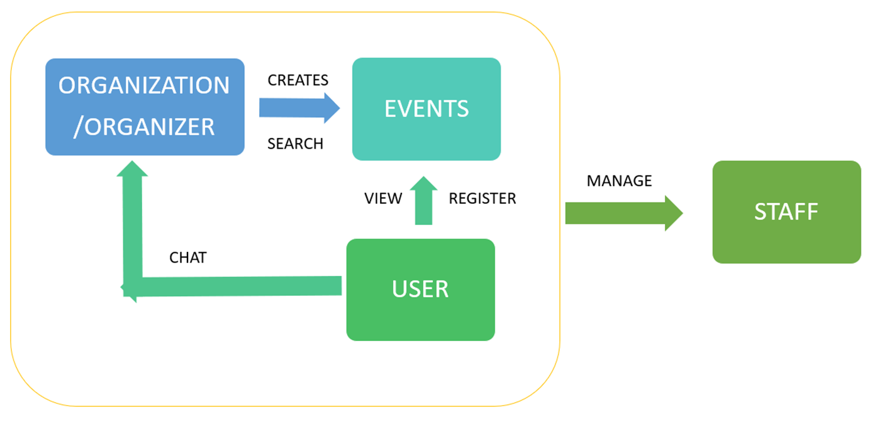

**4. Design**

**4.1 E-R diagram:(Revised)**

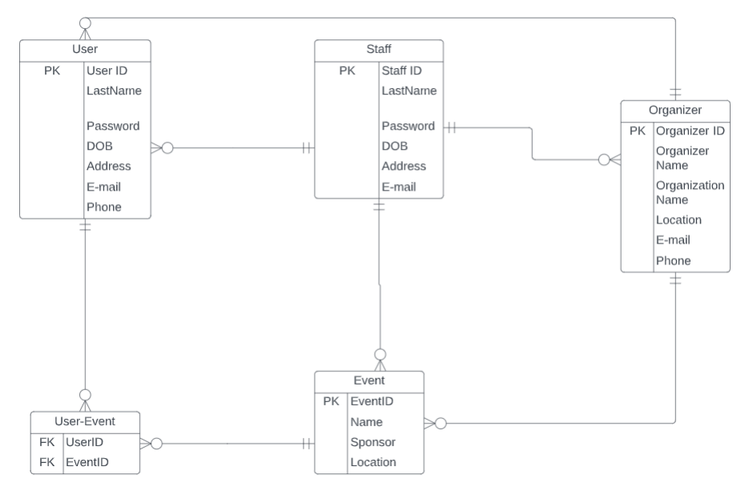

**GitHub repo link: https://github.com/DwithiPathi/EventTracking**

**5.Analysis Models**

**5.1 Data Flow diagram:(In page 6)**

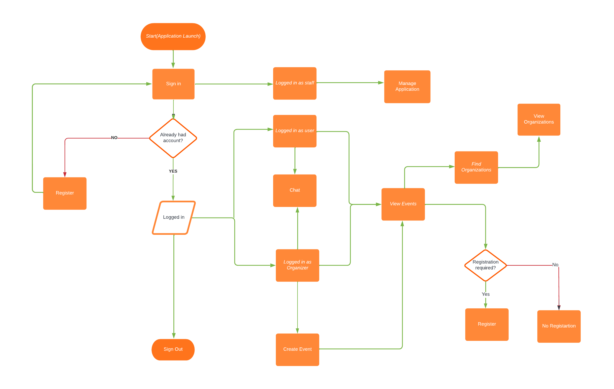

**5.2 Sequence Diagram:**

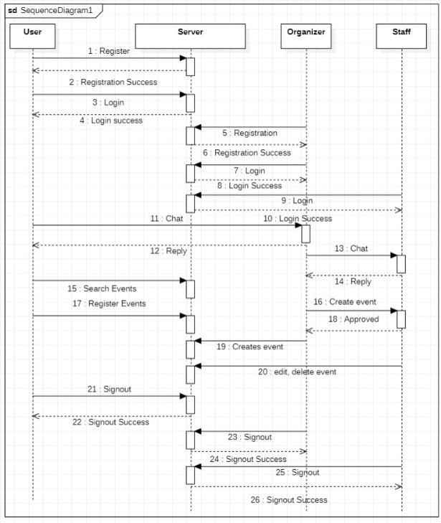

**6. Technical Manual**:

Event track is all about the events happening across us. Event tracking provides details of programs/events in nearby locations.This application helps users to track events and register for interested events and organizers to plan, execute and succeed any event. It provides one stop solution for event promotions.This application gathers trustworthy information from valid sources to serve users. It helps people to actively participate in the programs by stacking up all ongoing and planned events details by enhancing their network and also provides them volunteering opportunities.

EveTrac user domain includes event organizers and participants:

EveTrac organizer’s features: Create, Modify, Search, Filter, Delete events.

EveTrac user features: Register, Search, Filter, Promote, Enquire about events.

**React Commands Used:**

Install dependencies and packages:

In React, npm install is a command used to install dependencies and packages needed for a project. It is executed in the command-line interface (CLI) within the root directory of the React application .

Create React App:

create-react-app tool is used to create React applications and command used is:

npx create-react-app my-react-app

Run React App:

To initiate a React application, you have the option of using either the npm or yarn command, depending on which package manager was implemented in the project. If you're utilizing npm, you can begin the application by running "npm start". On the other hand, if you're using yarn as your package manager, you can begin the application by typing "yarn start".

Move to the directory command used is:

cd my-react-app

Execute the React Application command used is:

npm start

When we run the npm start command in a React application, a development server is started, and the application is opened in your default browser. The browser will display the application's main page, which is typically located at <http://localhost:3000/>.

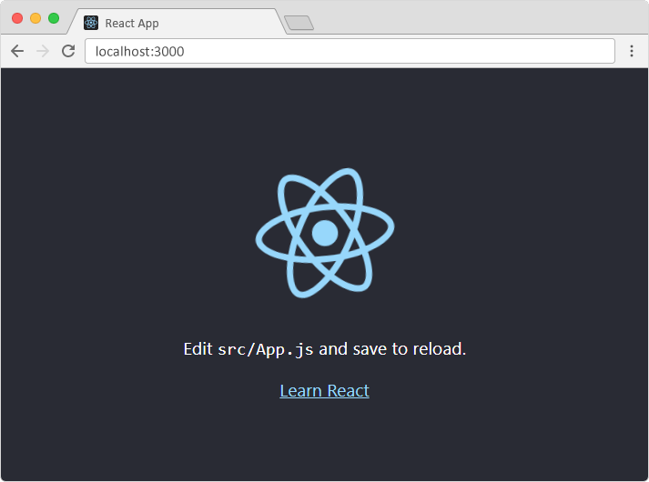

**App.js file:**

App.js is a key file in a React application that defines the structure of the user interface and serves as the entry point for the application's logic and state management.The App component defined in App.js is a React component that serves as the root component of the application. It is responsible for rendering other components and handling the application's state and logic.

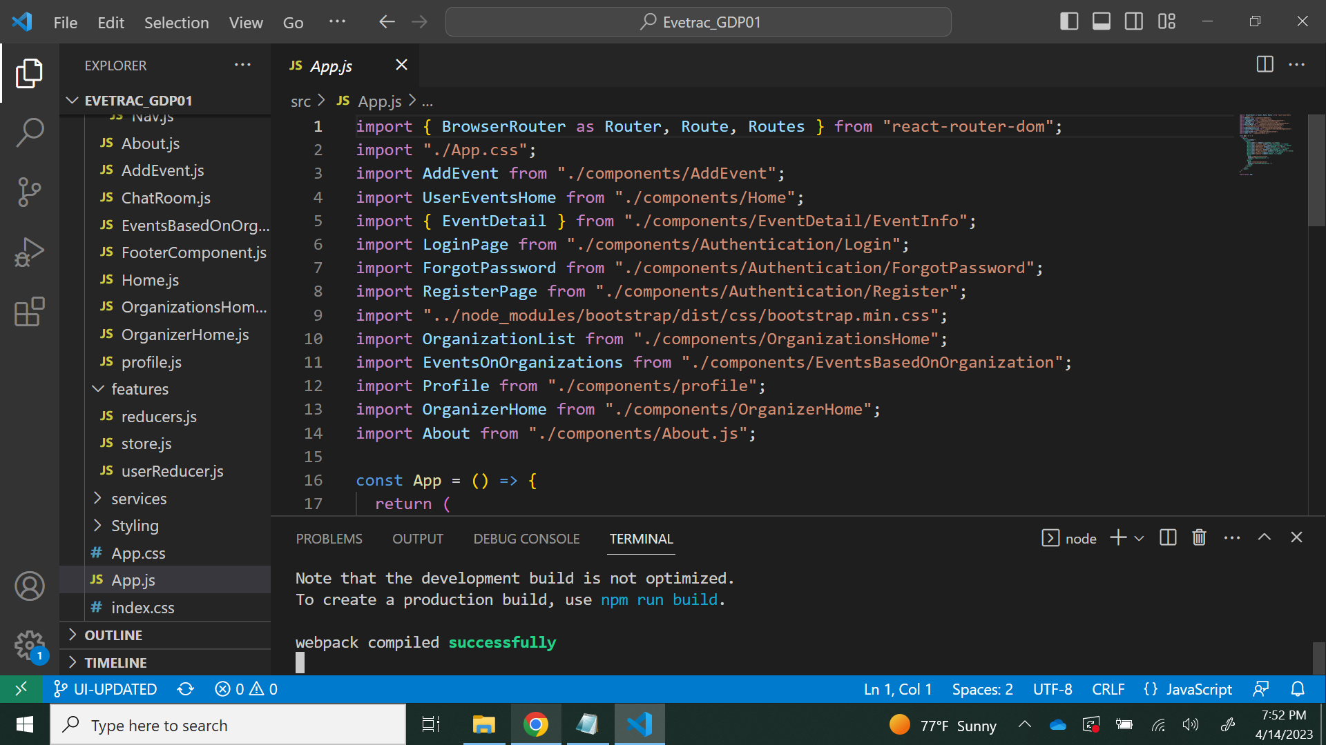

**API file:**

An API (Application Programming Interface) is a set of protocols, tools, and standards that enables different software applications to communicate with each other. In other words, an API acts as a bridge between software applications, allowing them to exchange information and work together seamlessly.

In the context of web development, an API typically refers to a set of web services that a server provides to allow other applications to interact with its backend functionality. The backend functionality is the part of an application or system that processes data and performs complex tasks, such as data storage, retrieval, and manipulation.

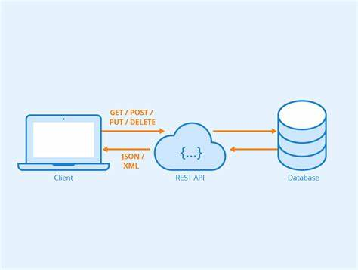

The backend functionality of an API can be implemented using a variety of server-side technologies, such as PHP, Python, Ruby, Java, or Node.js. These technologies enable developers to build robust, scalable, and secure APIs that can handle a large volume of requests and provide reliable service to clients.

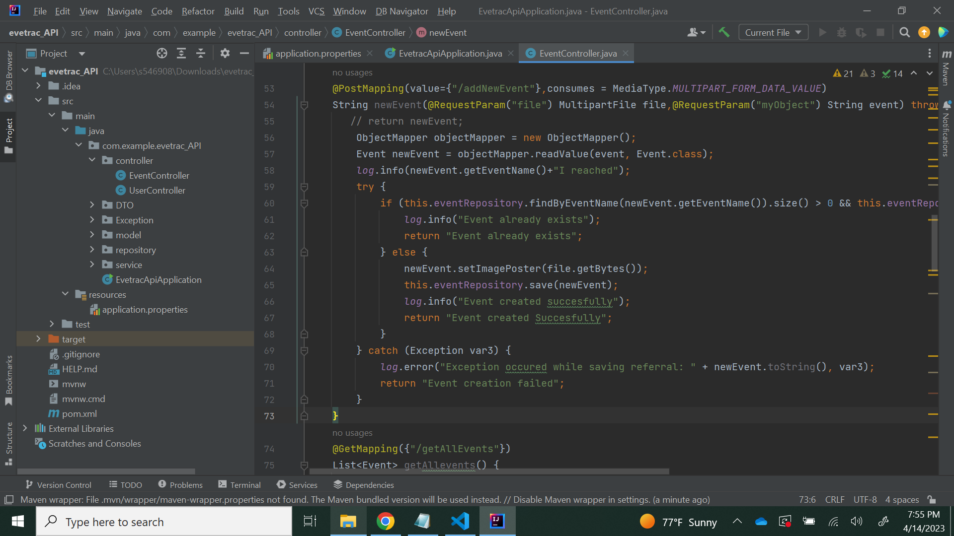

**DataBase Integration:**

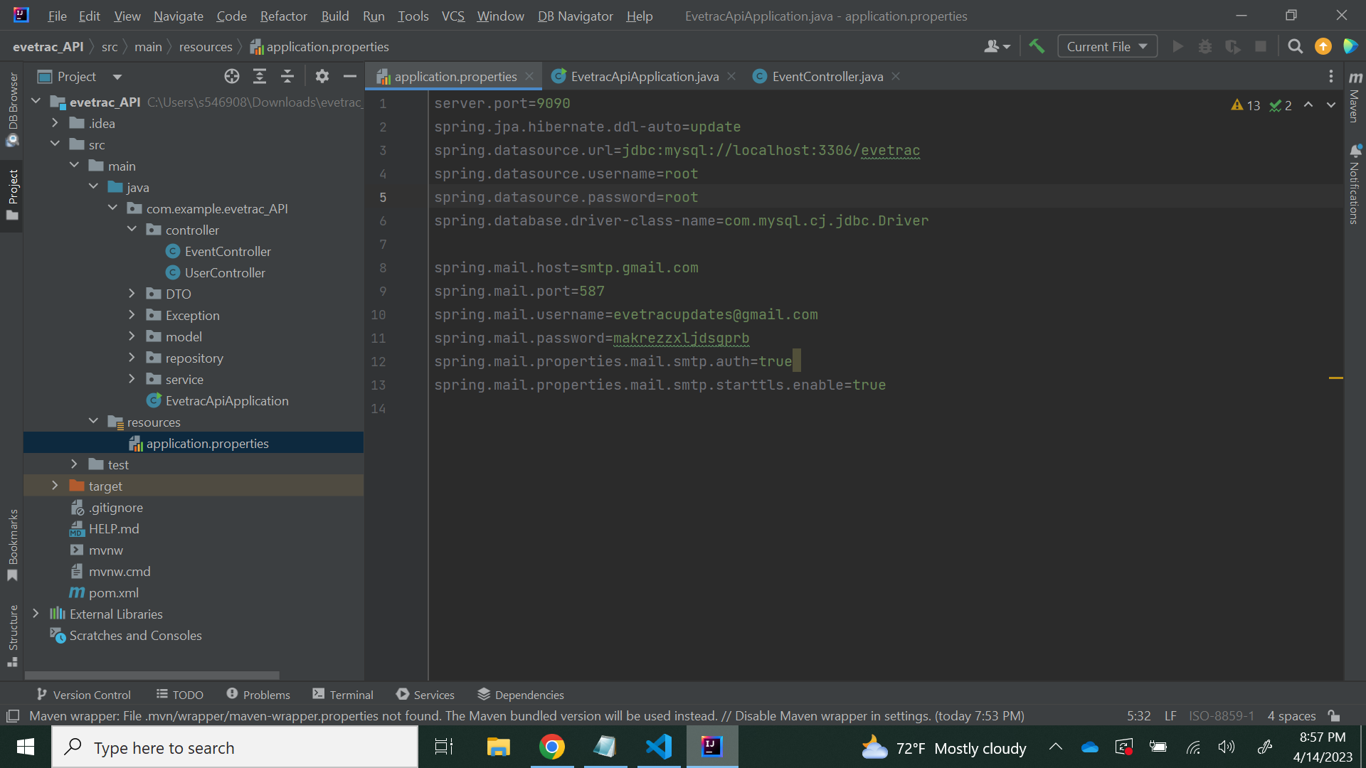

MySQL database integration for Spring Boot involves connecting a Spring Boot application with a MySQL database to store and manage data. This allows the Spring Boot application to access the data in the database and use it to perform various functions, such as displaying data on a website.

**Home Component:**

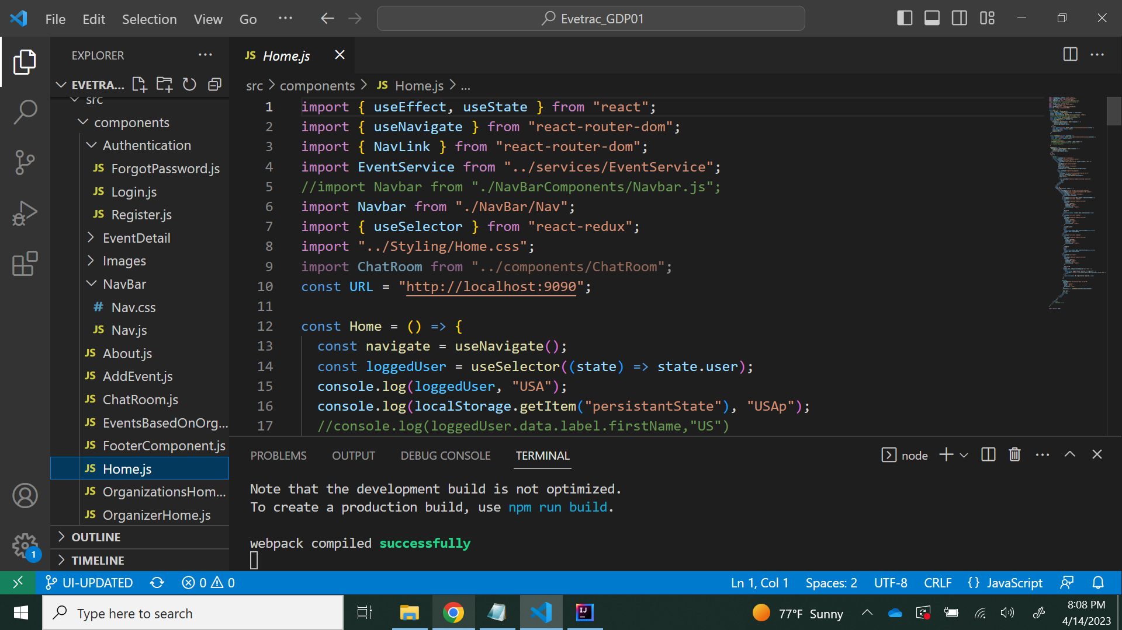

It contains code which displays all available events to users.

**Home Organizer:**

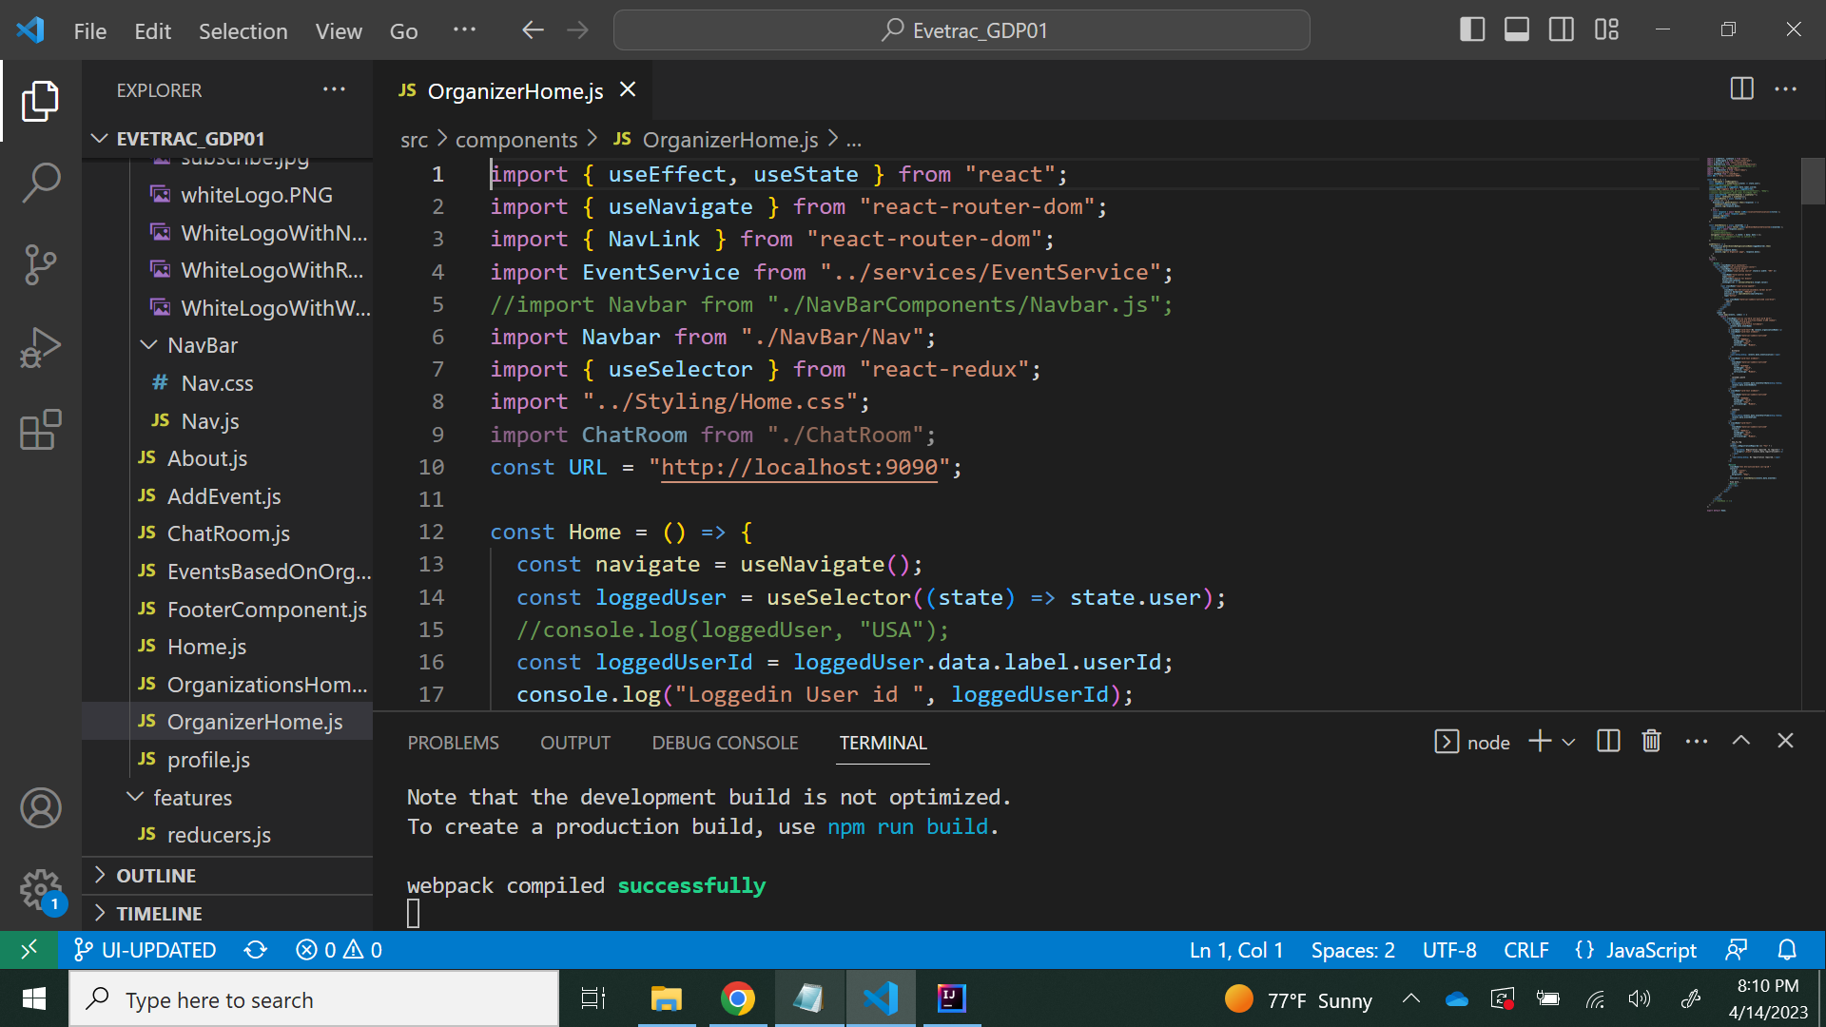

It contains code which displays all events which are created by the respective Organizer.

**NavBar:**

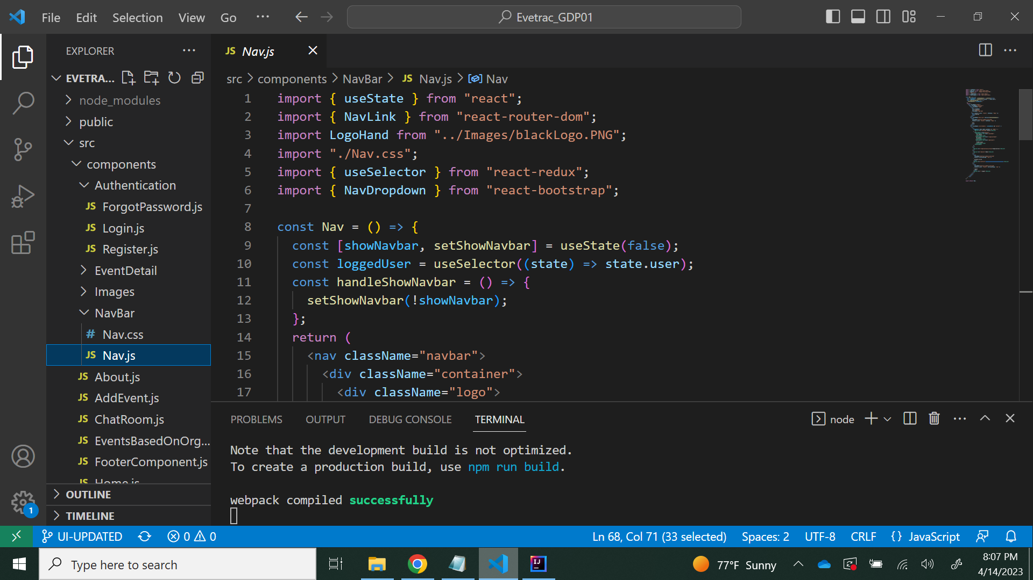

It contains code which is used to display the navigation bar to all pages.

**Chatbot:**

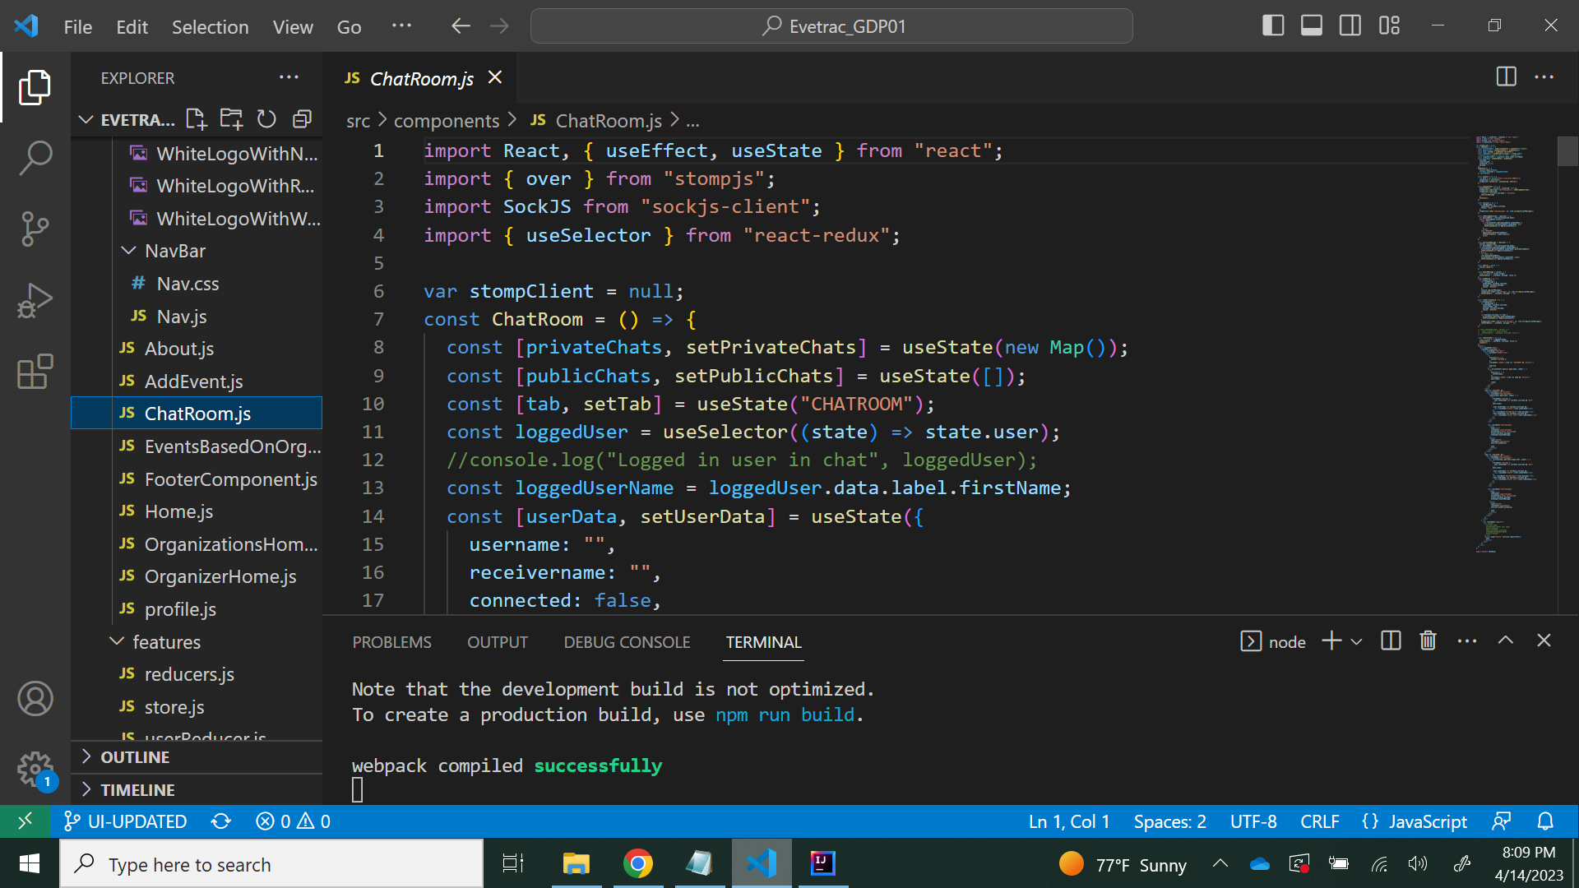

A chatbot is a program that can talk with users in a chat. It can help answer questions or do things for users, like queries about registration or about events. It allows communication between the User and the organizer.

**7. User Manual:**

**Login Page:**

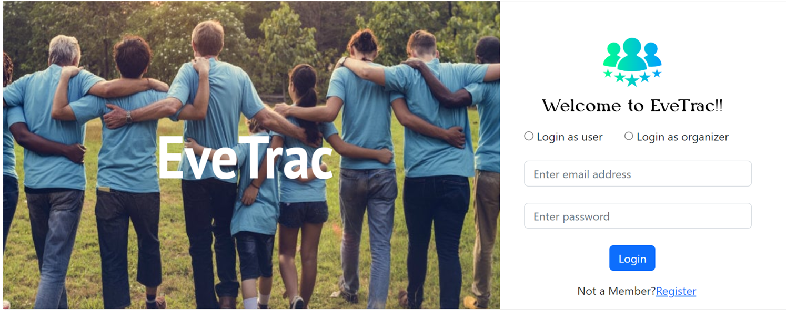

This screen helps user’s/organizer’s to login into the application. If the user/organizer didn’t have an account, by clicking the register, the register page will appear.

**Register Page:**

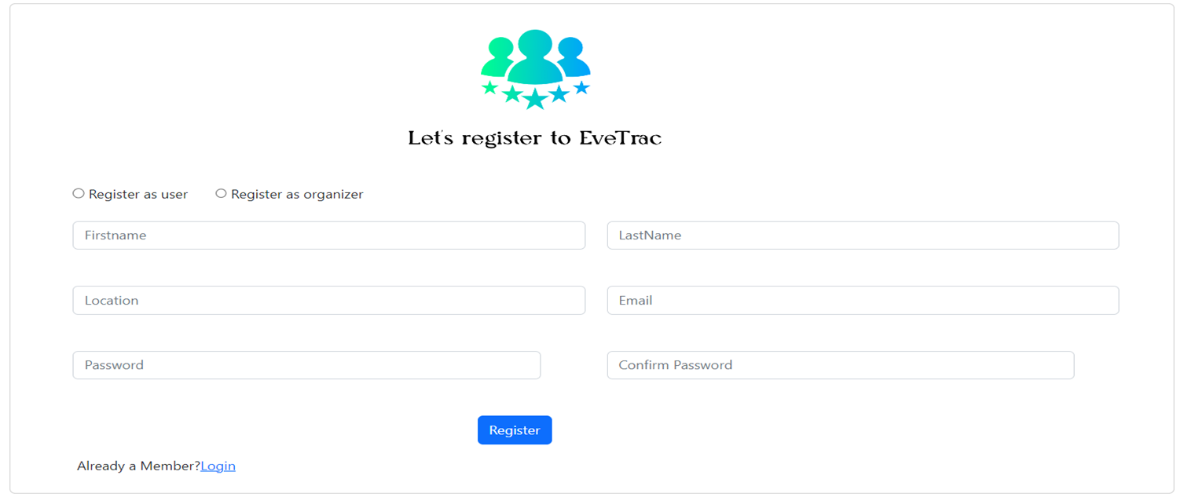

This screen is to collect user’s/organizer’s details and register them to the application.

**User Home:**

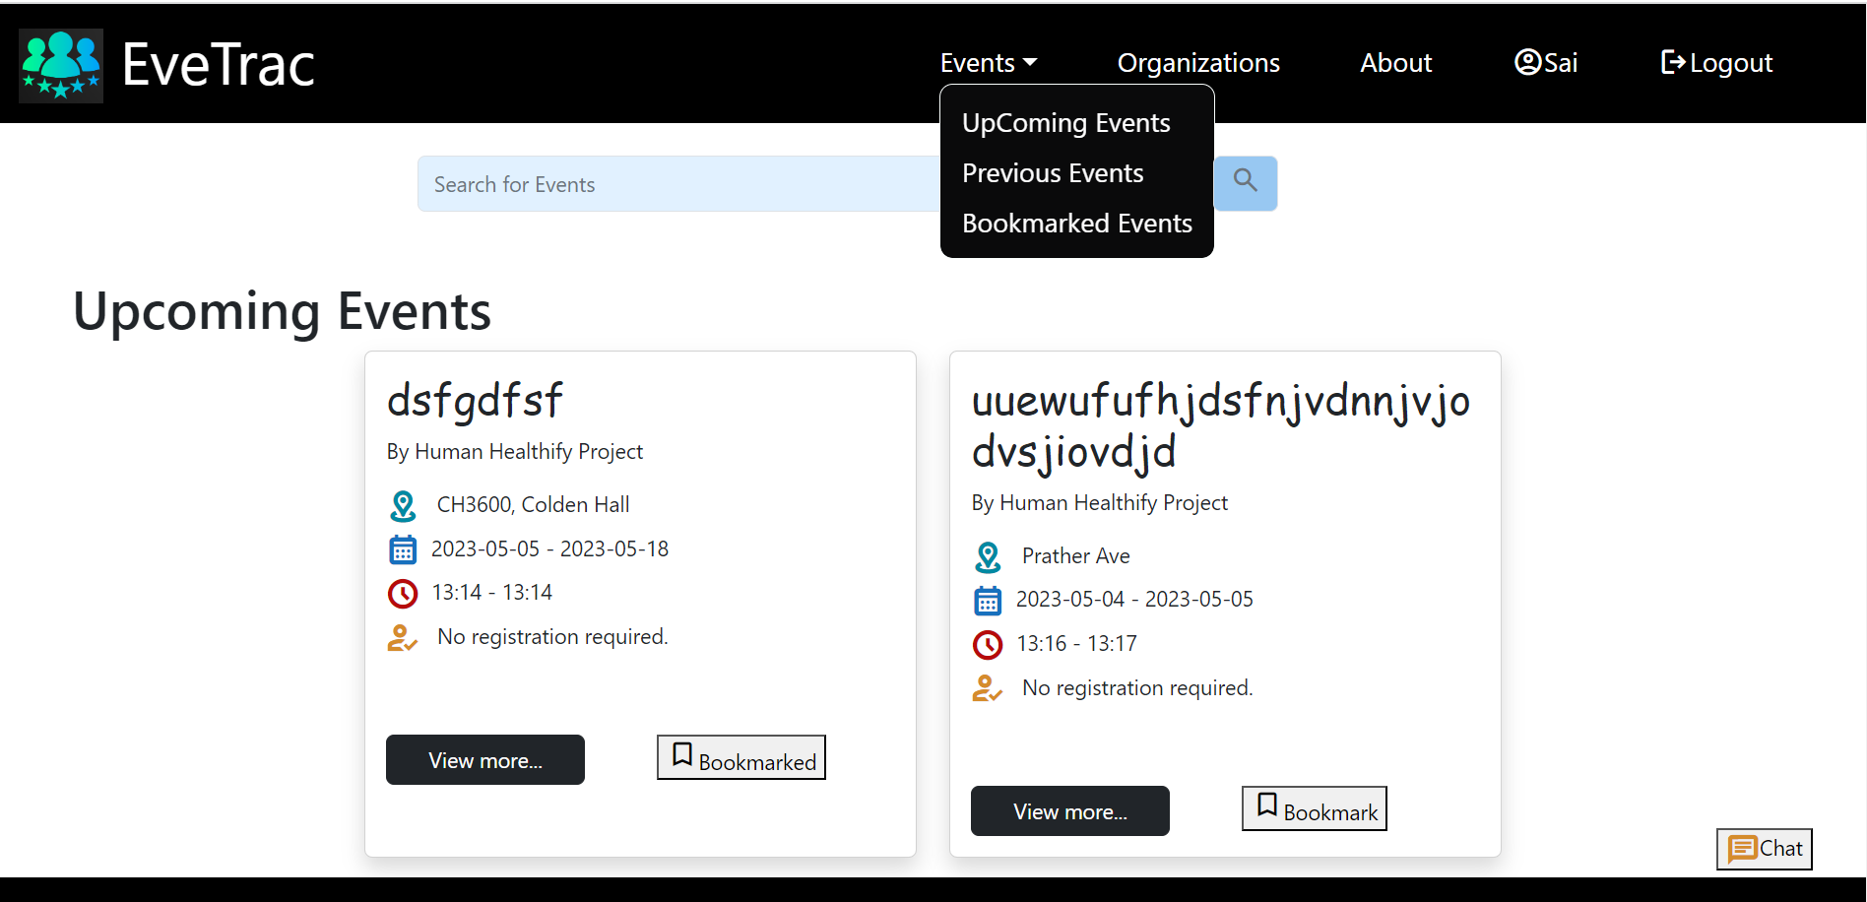

This screen is the user’s home- if the person logs in as a user this page will appear.

**Bookmarked Events:**

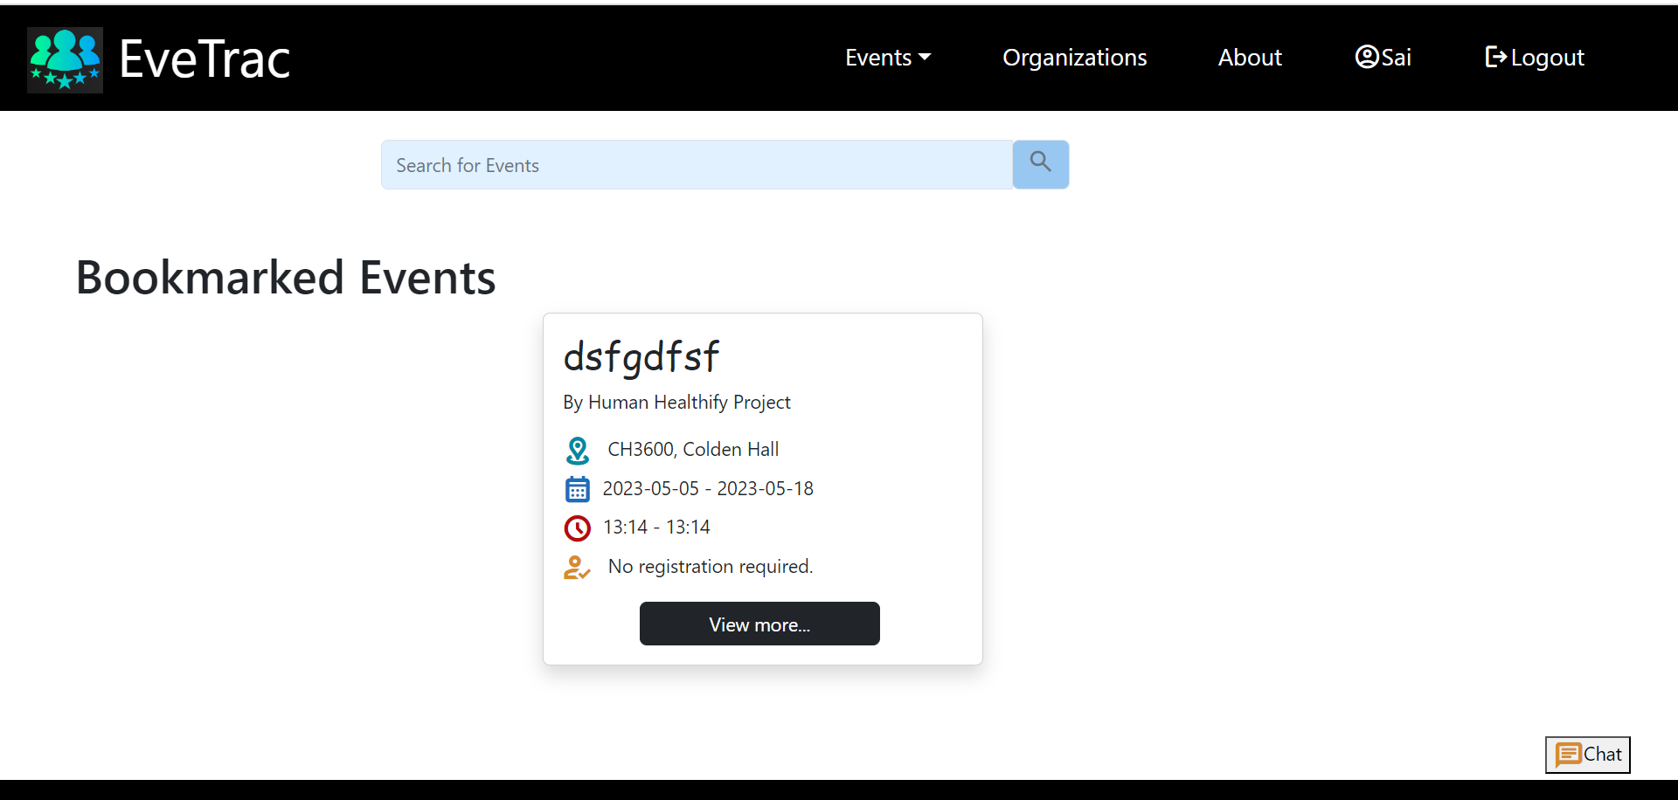

Users can add the events to their wishlist by bookmarking events. Those events are moved to the Bookmarked event.User can view it by selecting the bookmarked events from the dropdown .

**List of Organizations:**

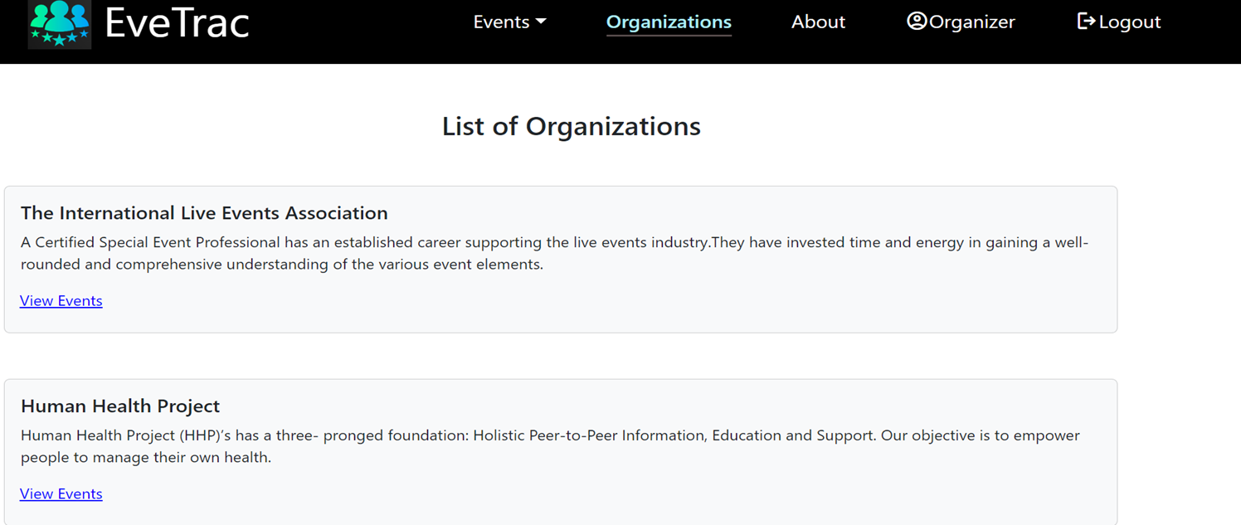

This screen gives a list of all organizations when the user/organizer clicks on the organization’s tab.

**Events based on Organization:**

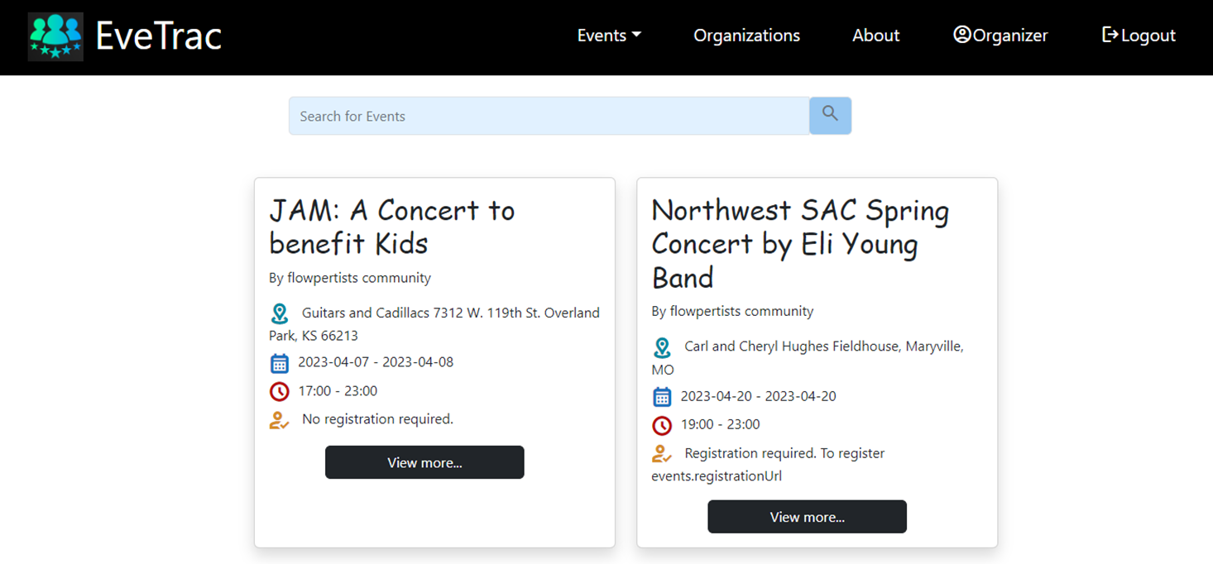

This screen appears if the user/organizer selects a specific organization then events held by that organization are displayed.

**Event Details for user:**

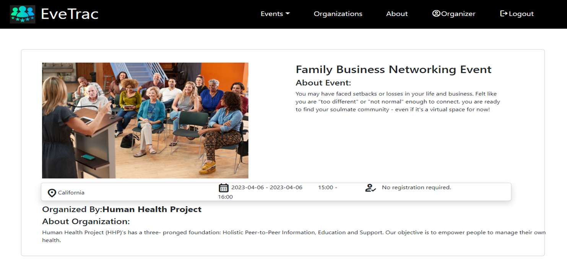

This screen gives a detailed overview of the event. It appears when the user/organizer clicks on “view more…” of an event.

**User-Profile Page:**

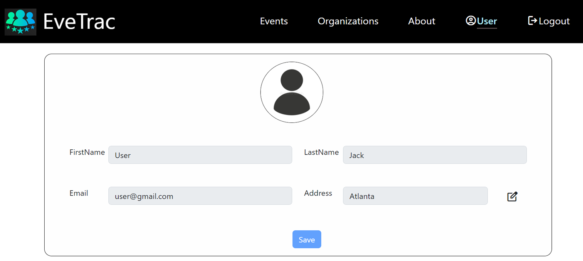

Profile page for user to update details.

**Organizer Home:**

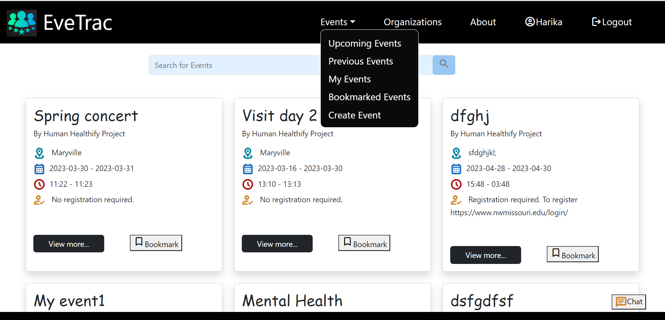

This screen is the organizer’s home- if the person logs in as an organizer lands on this page. In this screen, the organizer can create an event and can see the events created by him.

**Event Details for user:**

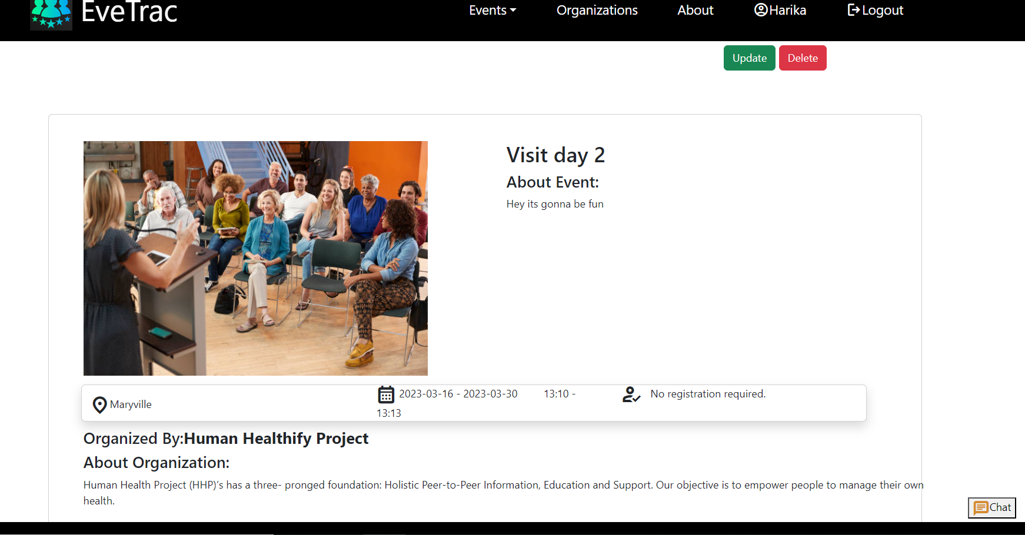

This is the event detail description page which shows event location, event date ,event time. Organizers have additional features to update and delete their own events using update and delete buttons.

**Event Update:**

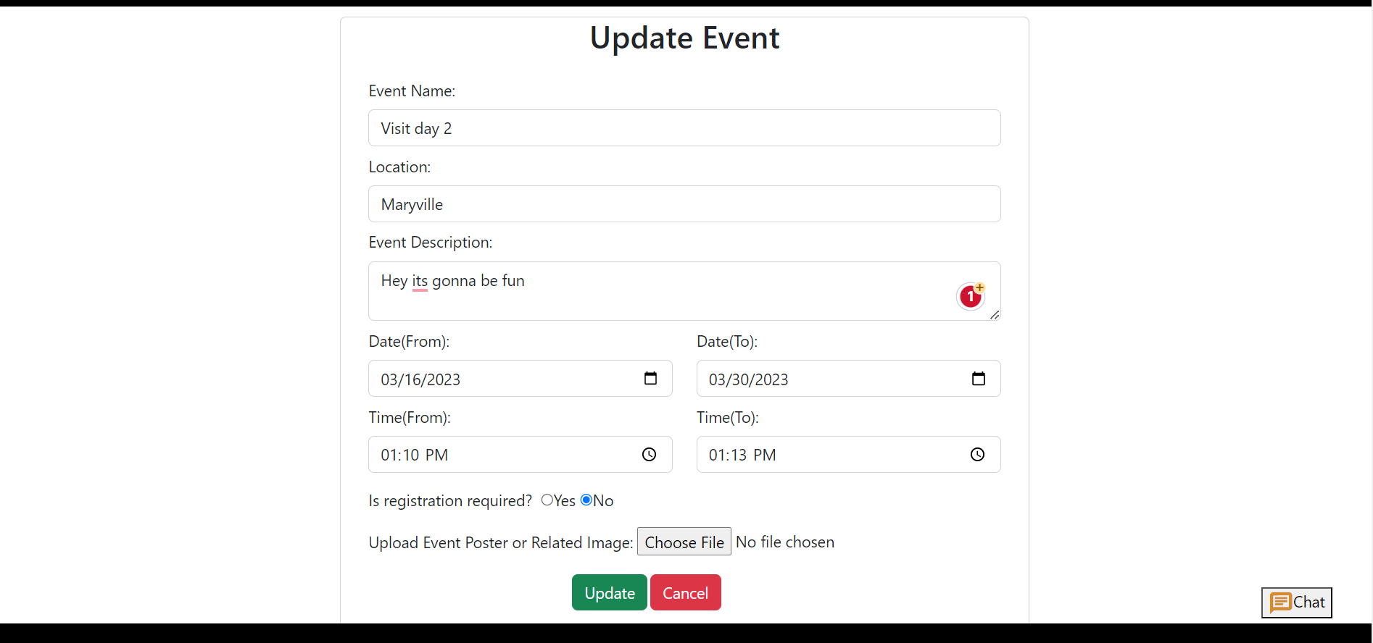

Organizers can update the event details on this page. Organizer can’t select the previous dates, and can’t edit already completed events.

**Event Creation:**

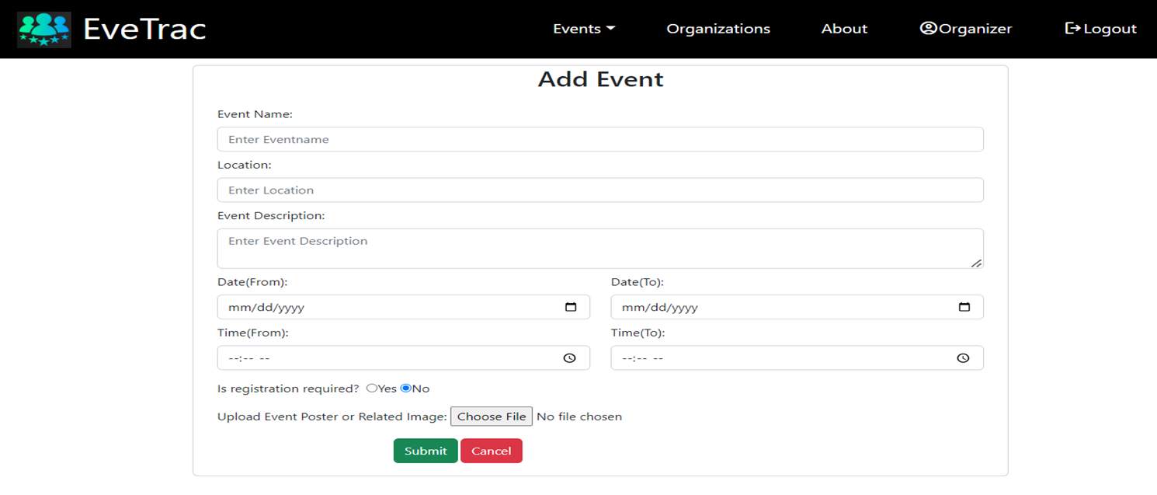

This screen appears if the organizer selects create event from the dropdown, then the organizer can create a new event.

**Organizer Profile Page:**

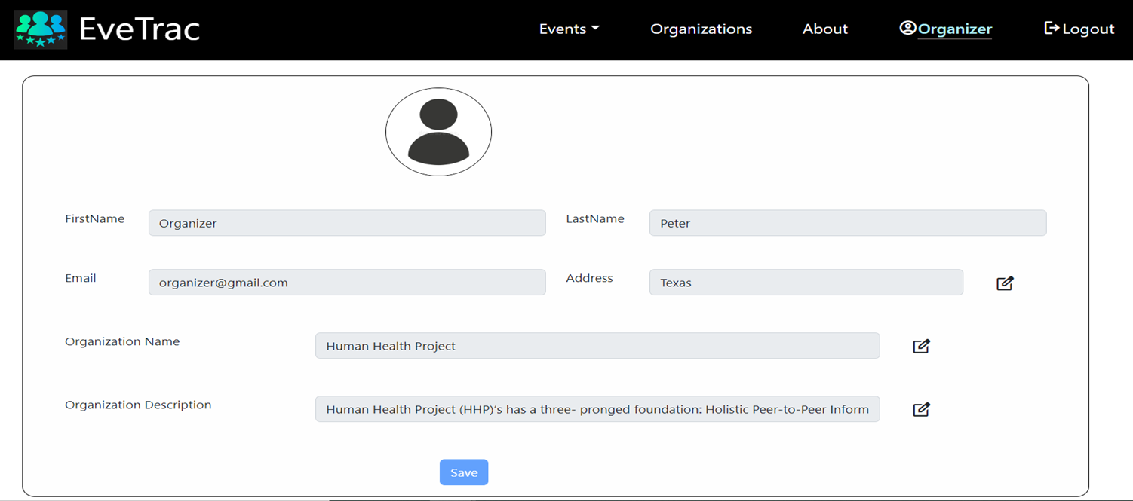

This is the Organizer's profile page where they can edit their profile.

**About:**

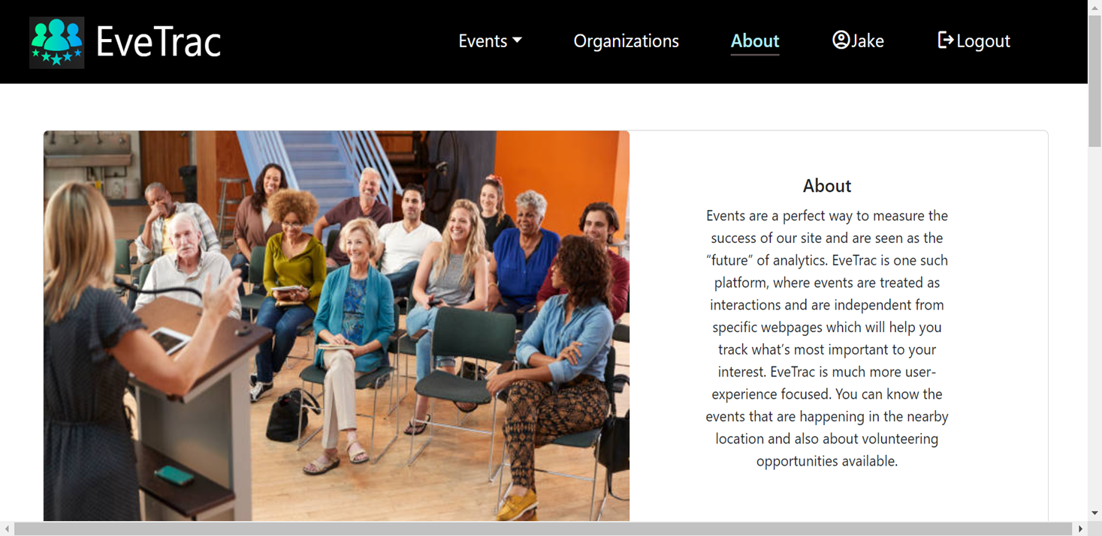

This screen provides the basic information related to the application and contact details.

**Search Functionality:**

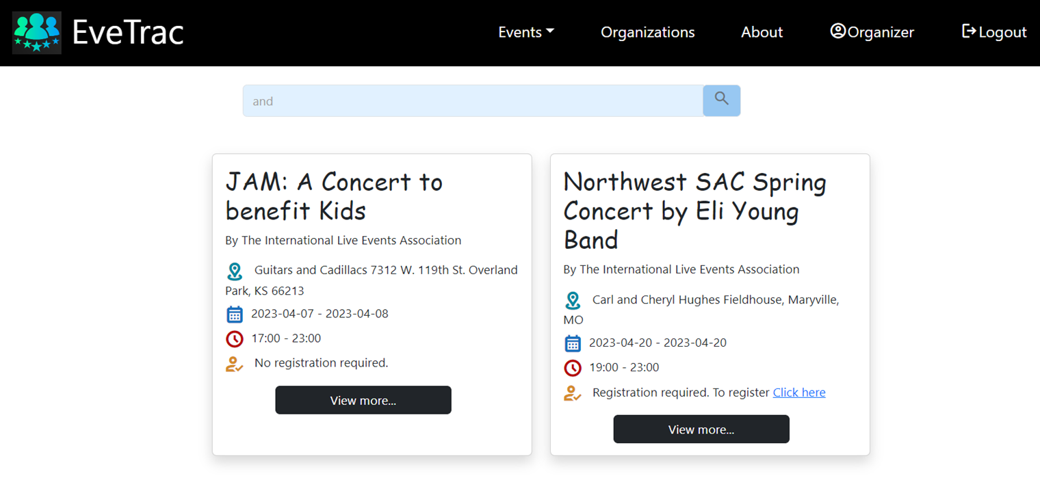

In this screen users can search the events based on the location.

**8. Conclusion:**

In conclusion, Event Tracking is an innovative web application that has revolutionized the way we manage and track events. Its user-friendly interface and intuitive design make it easy for anyone to use, regardless of their technical expertise.

With Event Tracking, users can easily create and manage events, track events and participate. This not only saves time and effort but also helps to improve event planning and execution.

Overall, Event Tracking is a powerful web application that can streamline event management and enhance the user experience. Its many features and benefits make it an indispensable asset for anyone looking to organize successful events.